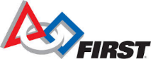
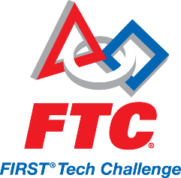

Dear Sir or Madame;

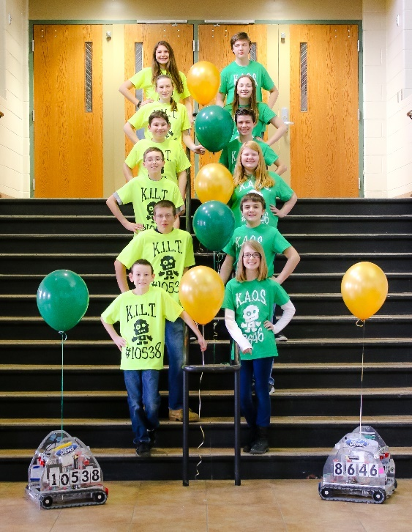
Howell Highlander Robotics would like to introduce you to FIRST® (For the Inspiration and Recognition of Science and Technology) Tech Challenge, “where every student can turn pro.” FIRST® combines the excitement of a sport with the rigors of science and technology. Under strict rules and a 6-week time limit, teams of middle school students are challenged to design, build, program, and operate robots, to play a floor game in an alliance format. At FIRST® Tech Challenge events, students realize that FIRST® is about more than robots; it’s about teamwork, sharing, helping others, and respect. It’s as close to real-world engineering and business as a student can get.
Guided by adult Coaches and Mentors, students develop STEM (Science, Technology, Engineering, and Math) skills and practice engineering principles, while realizing the value of hard work, innovation, and sharing ideas. In addition, the team must keep an engineering notebook, develop teamwork skills, participate in community service, create computer animation designs, and secure funding through sponsorship.
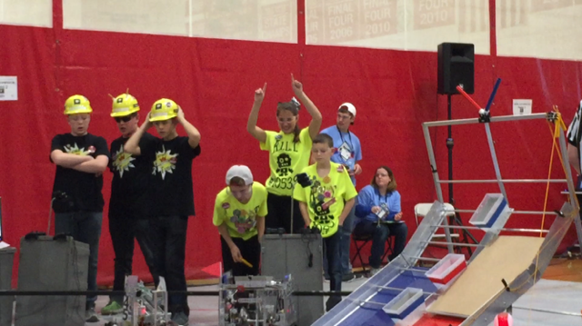
At FIRST®, learning never stops building upon itself, starting at age 6 and continuing through age 18. The FIRST® progression of programs includes Junior FLL (Junior FIRST® Lego League) for Grades 1-3, FLL (FIRST® Lego League) for Grades 3-5, FTC (FIRST® Tech Challenge) for Grades 6-8, and FRC (FIRST® Robotics Competition) for Grades 9-12. FIRST® Programs, even at an early age, positively impact students throughout their education and even into careers.

Currently, Howell Highlander Robotics fully funds and manages the progression of four teams. Our family of mentors, students, and coaches is comprised of an FRC team, SCOTS Bots team #4776, two FTC teams; Team KAOS #8646 and Team KILTS #10538, and one FLL team; The Viking Bots #18881. This year, our organization will grow by three as we welcome two new FLL teams and a Jr FLL team.
FIRST® Robotics works closely with research and academic organizations to provide tangible evidence of its impact on a student’s education and career choices. The positive impact on FIRST® Tech Challenge participants is gratifying and well documented. Over 84% of middle school students have more interest in school, 84% have more interest in taking a challenging math or science course, and 86% are more interested in attending college. It’s an amazing organization that fosters teamwork, self-confidence, and critical thinking while developing valuable partnerships and life skills. Additionally, it prepares students to continue their education in the STEM field and become valued employees of the future, for companies like yours.
As the importance of FIRST® grows, there is an increased demand for qualified engineers to lead Michigan, the country and the world into new technologies and innovations. There will 274,000 STEM jobs available in Michigan by the year 2018, as STEM jobs continue to grow 1.7 times faster than non-STEM jobs.
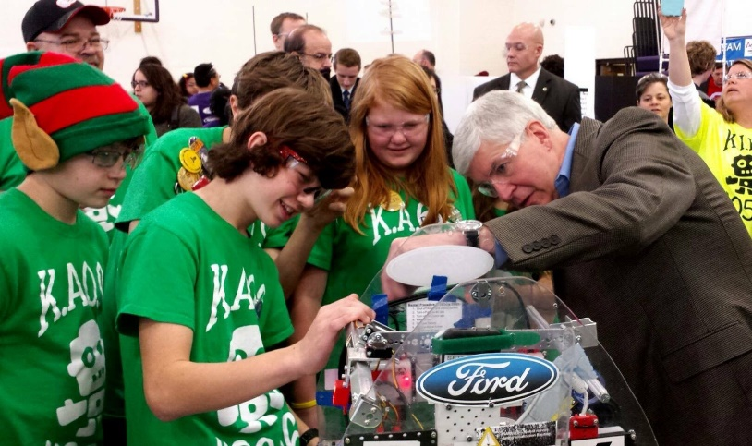
The Robotics program is mutually beneficial to the students and the companies that provide support. By sponsoring a FIRST® team, companies play a large role in increasing the number of students pursuing careers in STEM by exposing them to the excitement of real world engineering. Every contribution received means that more students can benefit from the amazing and unique opportunities that FIRST® provides. Providing students with opportunities that foster their imagination and enhance their knowledge of STEM guarantees their personal success and the future possibilities are endless.
Our organization gives sponsors an opportunity to increase their visibility locally and nationally, and give back to the community that has contributed to its success. S.C.O.T.S Bots has created several contribution categories that sponsors can participate in. Each requires a specific donation amount and places that sponsor’s name in specific locations on our robot, website, t-shirts, and banners. Every August, FIRST® releases a new FLL Challenge to ignite the creativity of elementary

school children worldwide. As we look forward to the thrill of a new challenge, and the anticipation of a new season, we also look to our annual budget.
Our FIRST® Tech Challenge budget is about $12,000 annually, (ie: $6000 per FTC team), to fund the robot kits and support additional team expenses, such as; t-shirts, laptops, educational supplies, and registration fees. We graciously accept donations in any amount, in the form of cash, goods, or services. We would greatly appreciate your consideration to join our team through sponsorship. The extension of an organizations name, reputation, and finances is a mutual, prestigious honor.
The FTC program is equally beneficial to the students and the companies that provide support. By sponsoring a FIRST® team, companies play a large role in increasing the number of students pursuing careers in STEM by exposing them to the excitement of real world engineering beginning at a young age.
We would be very pleased to partner with you and will strive to represent both of us with integrity, excellence, and innovation. We encourage you to check out our team’s website (www.scotsbots.org) and the FIRST® website (www.usfirst.org).
Thanking you in advance for your time and consideration regarding this important partnership. We look forward to hearing from you and appreciate your generous support for our future successes.
To make a tax deductible donation to Howell Highland Robotics, please make checks payable to Howell High Robotics. Mail donations to Howell High School, c/o Elaina Rocco-Hoxie, 1200 W. Grand River Ave, Howell, MI 48843. Please email your company logo to roccohoe@howellschools.com along with your donation.
For additional information about any of our Howell Highlander Robotics teams, or to schedule a robot demo, please contact Kim Portuesi at kmportuesi@comcast.net, or call 810-656-5850.
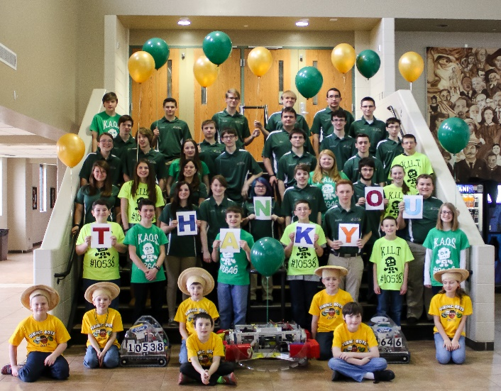
Sincerely,
The Mentors and Students of
Howell Highlander Robotics

